|  |  |
| --- | --- |
| Date | 5 November 2022 |
| Team Number | PNT2022TMID42645 |
| Project Name | Hazardous Area Monitoring in Industrial Plants |

Hardware components

Raspberry pi

Raspberry Pi, developed by Raspberry Pi Foundation in association with Broadcom, is a series of small single-board computers and perhaps the most inspiring computer available today.

From the moment you see the shiny green circuit board of Raspberry Pi, it invites you to tinker with it, play with it, start programming, and create your own software with it. Earlier, the Raspberry Pi was used to teach basic computer science in schools but later, because of its low cost and open design, the model became far more popular than anticipated.

It is widely used to make gaming devices, fitness gadgets, weather stations, and much more. But apart from that, it is used by thousands of people of all ages who want to take their first step in computer science.

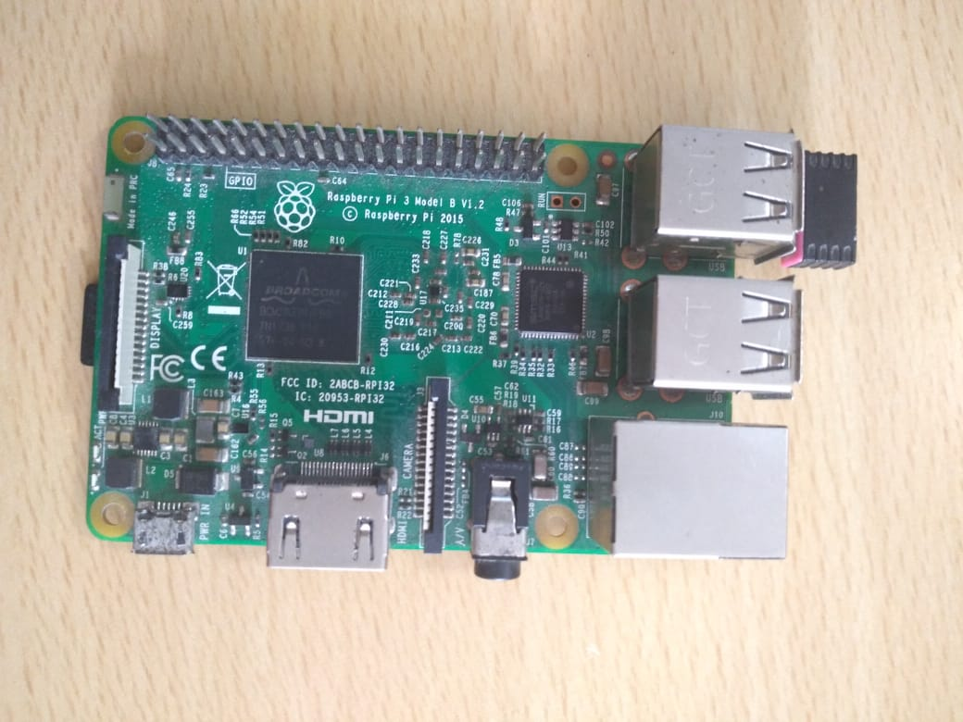

DHT11 temperature and humidity sensor

This DHT11 Temperature & Humidity Sensor features a temperature & humidity sensor complex with a calibrated digital signal output. By using the exclusive digital-signal acquisition technique and temperature & humidity sensing technology, it ensures high reliability and excellent long term stability. This sensor includes a resistive-type humidity measurement component and an NTC temperature measurement component, and connects to a high performance 8-bit microcontroller, offering excellent quality, fast response, anti-interference ability and cost- effectiveness

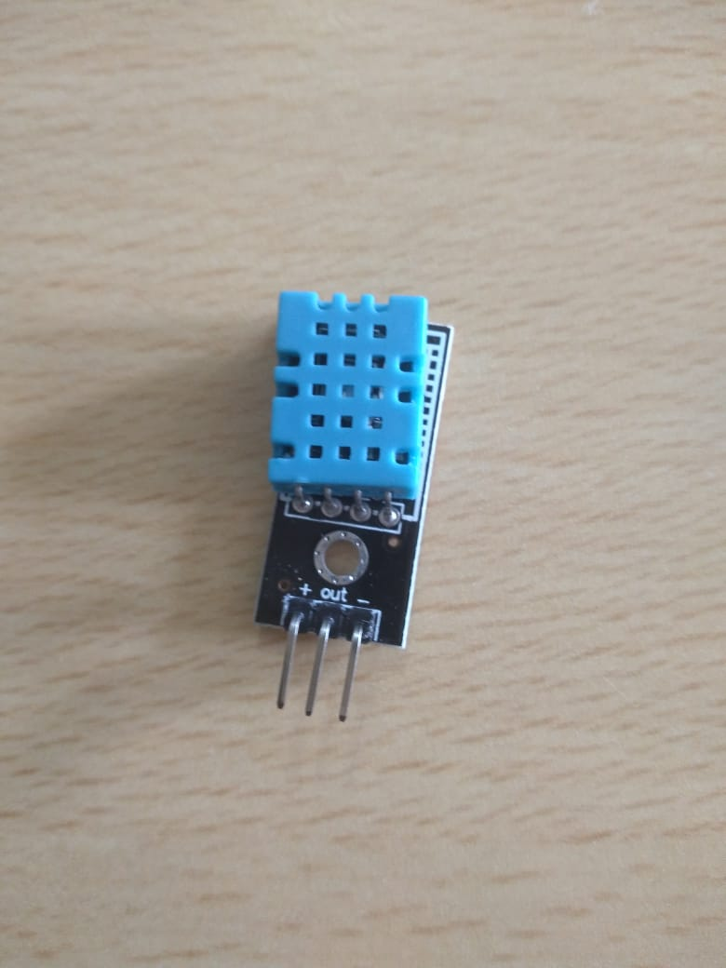

ESP8266

ESP8266 offers a complete and self-contained Wi-Fi networking solution, allowing it to either host the application or to offload all Wi-Fi networking functions from another application processor. When ESP8266 hosts the application, and when it is the only application processor in the device, it is able to boot up directly from an external flash. It has integrated cache to improve the performance of the system in such applications, and to minimize the memory requirements.

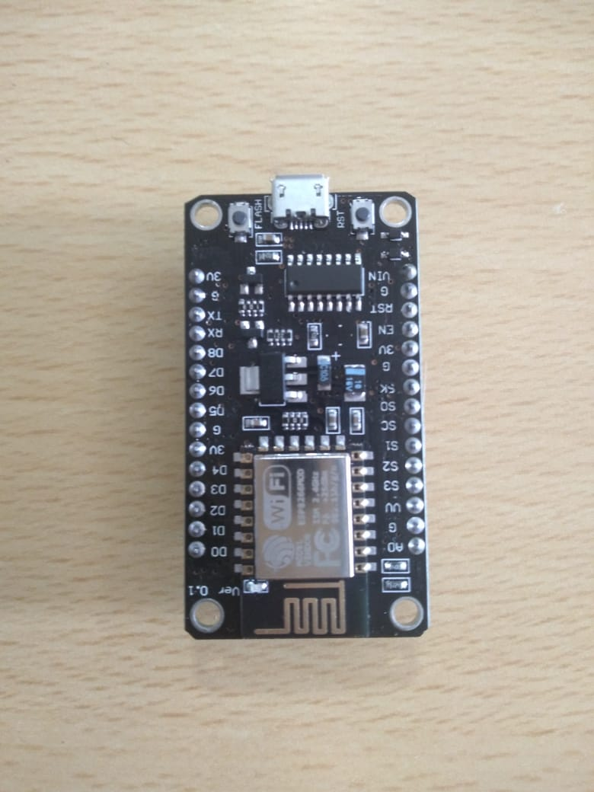

Connecting wires (female to female) and Data cable:

